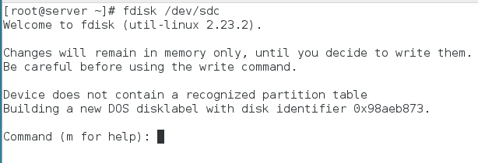

*Replace /dev/sdc with your disk.*

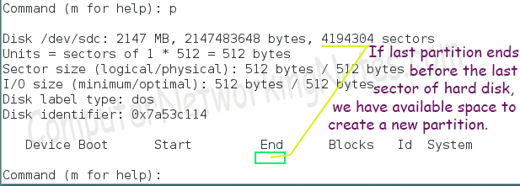

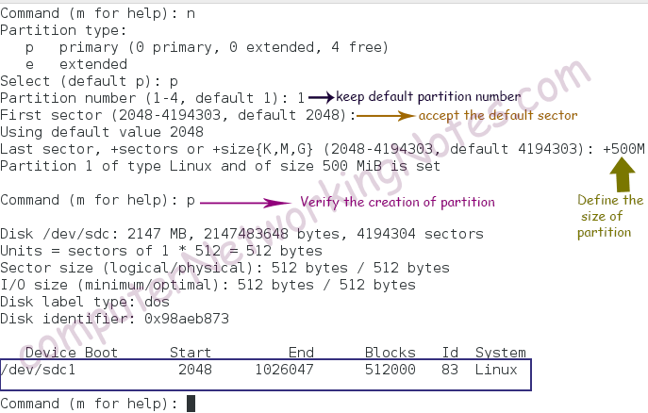

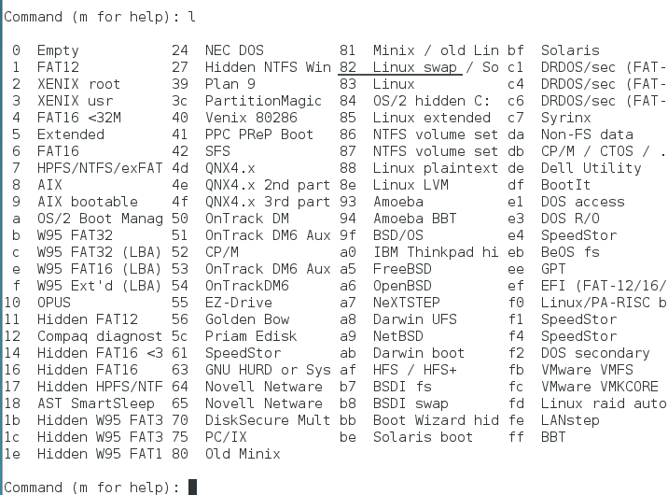

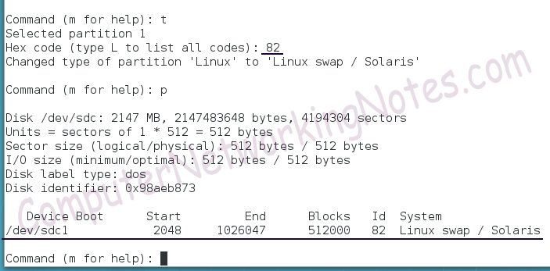

The fdisk will not save anything in disk until we confirm the action. To accept the change type **w** and press Enter key

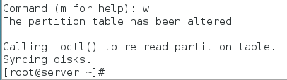

The fdisk cannot update the in-memory kernel partition table. Run following command to force the kernel to reread the partition table.

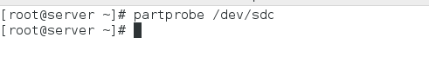

Formatting swap partition

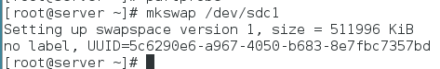

**swapon –s** :- This command display the status of swap space.

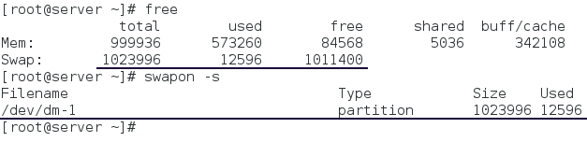

Activating swap partition

swapon [device_name]

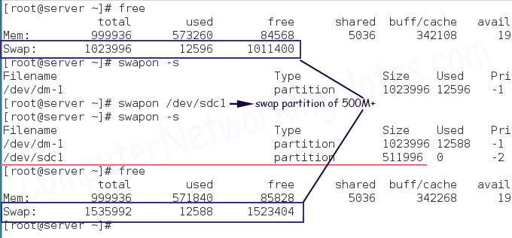

Mounting swap space permanently

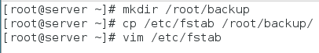

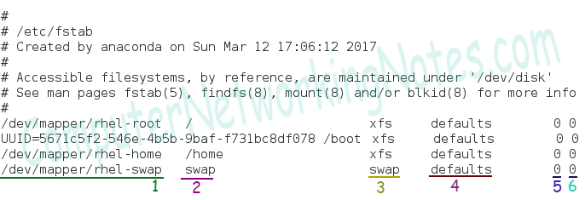

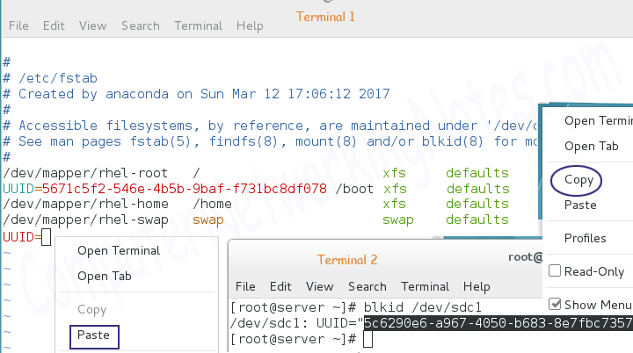

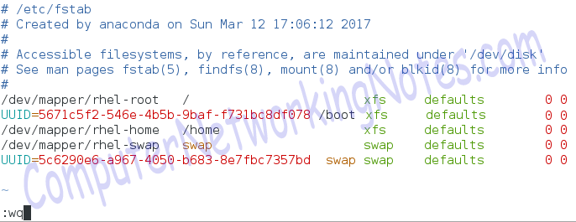

reboot the system

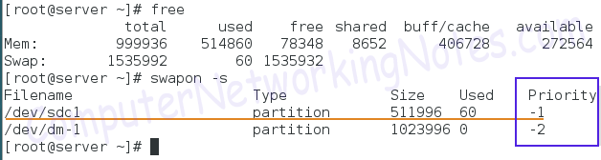

Removing swap space partition

#swapoff /dev/sdc1

We took the backup of */etc/fstab* file before starting this practice. We can either restore that file back or can delete swap partition entry from current file.

